WeatherPy Observations

Shaymus McTeague

We are trying to discover "What's the weather like as we approach the Equator?" In doing this I’ve been asked to find trends of relationship between Latitude and the subsequent Temperature (F), Humidity, Cloudiness and Wind Speed of various cities. After finding the trends for the date of the where the test was taken (7th of January 2020) we were able to pull some observations.

My first observation is that the temperatures along the Equator are tending in the high range. Though there are some temperatures outlying higher than the equator, those outliers are in the Southern Hemisphere where it is currently summer; and we’d expect high temperatures in a summer climate. An extension of this first observation that I find interesting is how close the summer climate and Equator climate are to one another, but that the winter climate diverges so much. I would like to collect data over time periods to see how these plots differ during the various seasons; and see what it looks like when the Northern Hemisphere is in a summer season. From this one snapshot, I would reason to believe the Equators temperature stays quite stable, while the two hemispheres vary quite a bit.

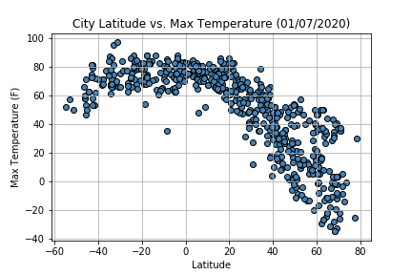

My second observation is related to the humidity (as a percentage). It appears to me that cities on or near the Equator tend to have a higher humidity percentage. Though both northern and southern hemisphere cities have varying amounts of humidity, those cities close to the Equator don’t deviate far from 60%+ humidity. Known as “tropical weather”, the cities near the Equator are known for high rates of humidity. We’ll also notice a high concentration of cities with high humidity in northern latitudes, which may contribute to typical winter weather – but we must remember this is simply a snapshot and cannot draw too many conclusions.

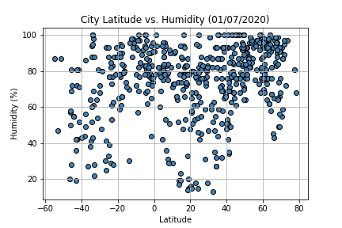

My final observation concerns the Cloudiness and Wind Speed plots. In short, it seems there is little linear correlations in both, but that doesn’t mean that there is nothing interesting in them.

1. Within Latitude vs Cloudiness: it’s interesting to see that near the Equator there are very few cities with 0% cloudiness. Perhaps this is the “Tropical” climate, but we also know there are cities along the Equator that have very arid climates; including those in North Africa. Perhaps those are the few lying right near 0 Lat & 0% humidity.
2. Within Latitude vs Wind Speed: this one didn’t have too much jump-out at me, except for some of the outliers. There were a handful of high winds in northern latitudes, presumably related to winter weather. And fewer in southern latitudes, perhaps related to the Australian brush fires? I’d have to dig into the data to find that.
3. Within Latitude vs. Cloudiness: I come back to this plot because many of the numbers run along lines (e.g. 0%, 20%, 80%, etc.), which leads me to believe it is a statistic that is decided by a human being; meaning there is inherit bias, but we can assume it is *fairly close* to a good measure of cloud coverage.

